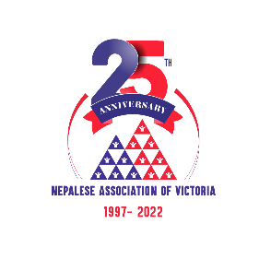

**NAV 25th Anniversary Press Meet Date 10/03/2022**

Dear Everyone Namaste !

NAV would like to hold a Press Meeting and kindly invite you to the meeting and share the upcoming NAV 25th anniversary event program. Your support and role are crucial to the success of the program and dissemination of the event to social media and media outlets. The meeting details are as follows

Date: Tuesday March 15th, 2022

Time: 7pm

Venue: Zoom meeting.

Meeting agenda

* Purpose of the Meeting - Niru Tripathi
* NAV 25th Anniversary event- Welcome and overview progress Ram Gurung
* Significance of the Event- Dr Raju Adhikari
* Media and publication= jog Limbu
* Event program: Ranja Vaidya
* Publication: Sudhir Shakya
* Guest Management- Bom Yonzon
* Ticket Sale: Tara Giare
* Grant information: Dr. Yakindra Timilsena
* Q&A session
* Closing Remarks- Jog Limbu

**Ram Gurung**

**President**

**Nepalese Association of Victoria Inc.**